Host Discovery With Nmap

-sn = ping scan
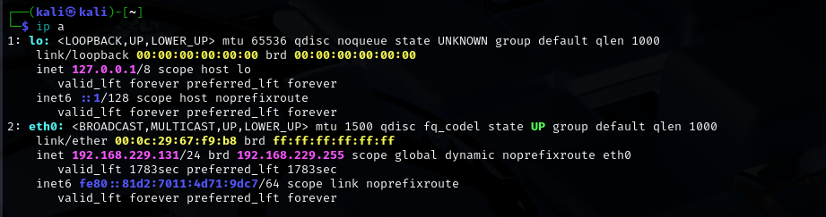

• -sn: Ping scan only (no port scanning)
• Shows live (up) hosts in that subnet

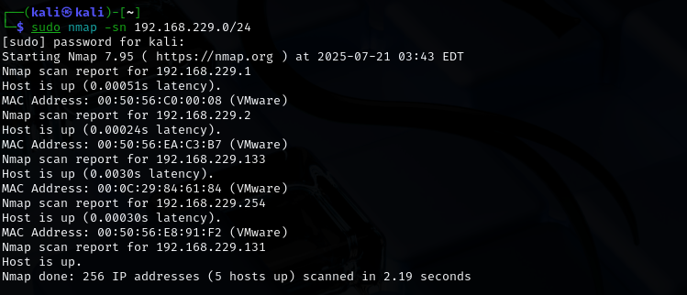

And after that we perfmro the port scan on each of them and then search for more.

Another tool for that is
Netdiscover it work on the ARP packets.

sudo netdiscover -i eth0 -r 192.168.229.0/24
